ZHorde Surival

Date: 04/11/2018

Author: Mihail Uzunov

# Introduction

## Pitch

A simple 2D zombie survival game featuring self-expanding level system, an AI with different type of enemies and multiple guns and character leveling.

The game is built in C++ with SDL2 and custom engine architecture.

# Game

## Game Features

### Procedural Level Design

The game will feature a self-expanding level design. The size of the level will be based of the wave the player currently is. It will be built randomly and procedurally. Each time a wave finishes the terrain will expand, thus giving the player more room to move.

The main tiles of the map will be represented by

Main walkable tile:

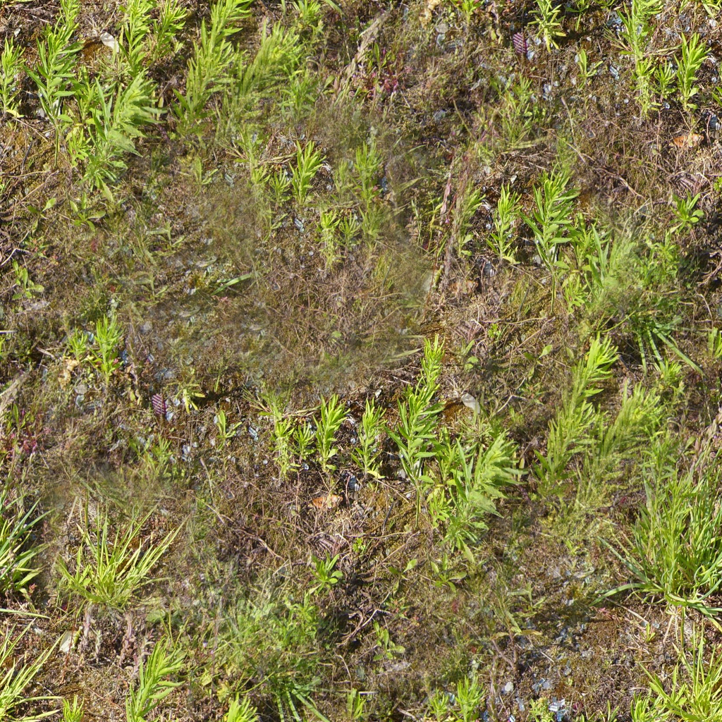

Tile that marks the border where the player will be hitting the edge:

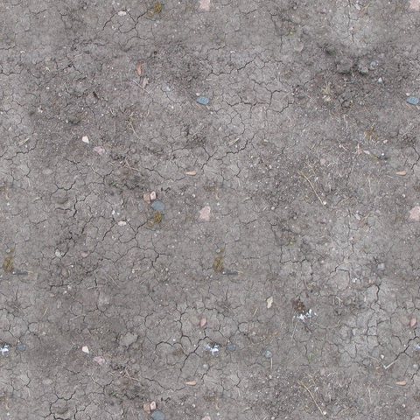

Tile that will be blocking the player

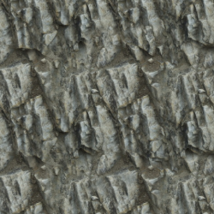

Random parts of the Walkable tile will be spawned with some kind of foliage that the player will be blocked by.

[A sample foliage collection](https://opengameart.org/content/top-down-foliage-collection)

And some parts of it must spawn randomly and rarely some bonuses with a destroyable box by the player:

[Wooden Crate](https://opengameart.org/content/wooden-crate)

All of the tiles must be built in specific way. Each tile will be represented as 64x64 pixels tile that the player can walk on.

### Enemies & AI

The game will feature 3 types of enemies that have different attributes. Each enemy will be defined by X attributes that are:

* Health – The amount of hits it can take before it dies
* Speed – How fast the enemy will reach the player
* Attack – How much damage per hit it can deal to the player

The enemy types are:

#### Walker

[Walker Animated](https://opengameart.org/content/animated-top-down-zombie)

A simple and easy to kill enemy. No special skills

|  |  |
| --- | --- |
| Walker | |
| Health | 10 |
| Speed | 5 |
| Attack | 5 |

#### Bloat

[No asset for it]

A hard to kill enemy. Very slow, hits hard and will blowup if dead.

|  |  |
| --- | --- |
| Bloat | |
| Health | 30 |
| Speed | 2 |
| Attack | 10 |

#### Crawler

[No asset for it yet]

A really fast enemy. If hits the player will cause bleeding for 3 seconds

|  |  |
| --- | --- |
| Crawler | |
| Health | 15 |
| Speed | 10 |
| Attack | 5 |

### Player

[Player representation](https://opengameart.org/content/animated-top-down-survivor-player)

The character will take the name of the player on game startup in main menu. He will have 4 possible weapons in the game that is:

* Knife – A melee weapon with short range. Backup weapon if all other ammo is empty.
* Pistol – The starter weapon of the player. Will start with 1 + 2 magazines.
* Shotgun – A large spread cone weapon that will kill off several enemies at once
* Assault Rifle – A very fast and accurate automatic rifle that will rip through the enemies.

Weapons will be represented by the following attributes

* Range – how far the bullet can travel
* Damage – how much damage it causes per shot
* Reload time – how fast the player can reload

#### Knife

|  |  |
| --- | --- |
| Knife | |
| Range | 1 |
| Damage | 2 |
| Reload time | 0 |

#### Pistol

|  |  |
| --- | --- |
| Pistol | |
| Range | N/A |
| Damage | N/A |
| Reload time | N/A |

#### Shotgun

|  |  |
| --- | --- |
| Shotgun | |
| Range | N/A |
| Damage | N/A |
| Reload time | N/A |

#### Assault Rifle

|  |  |
| --- | --- |
| Assault Rifle | |
| Range | N/A |
| Damage | N/A |
| Reload time | N/A |